# Company Profile

|  |  |
| --- | --- |
| Name | Lincoln Electric |
| Address | 22801 St Clair Ave, Cleveland, OH 44117, USA |
| Experian ID | 12345678 |
| Subsidiaries | Harris, Weldline, Saffro, Oerlikon |
| Branches | 19 countries |
| Ultimate Parent | Lincoln Electric |
| SIC Code | 3548 - Electric and Gas Welding and Soldering Equipment |
| Business type | Incorporated |
| Experian file established | 1997 |
| Years in business | 125 years + |
| Total employees | 500 |
| Date of Incorporation | 2nd December 1997 |

# Experian Credit Score

**Business Credit Scores range from a low of 1 to high of 100 with this company receiving a score of 60.**

Higher scores indicate lower risk. This score predicts the likelihood of serious credit delinquencies within the next 12 months. This score uses tradeline and collections information, public filings as well as other variables to predict future risk.

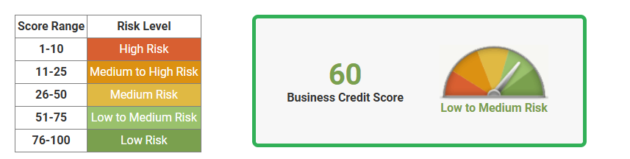

Business Credit Score is calculated by a statistically derived algorithm, designed to determine risk based on multiple factors including:

* Credit: Number of trade experiences, balances outstanding, payment habits, credit utilization and trends over time
* Public Records: Recency, frequency and dollar amounts associated with liens, judgments or bankruptcies
* Demographic Information: Years on file, Standard Industrial Classification (SIC) code and business size

# Credit Score Comparisons

|  |  |  |  |  |  |  |  |  |  |
| --- | --- | --- | --- | --- | --- | --- | --- | --- | --- |
| **Date** | **Current** | **Feb’25** | **Jan’25** | **Dec’24** | **Nov’24** | **Oct’24** | **Sept’24** | **Aug’24** | **July’24** |
| This company | 60 | 53 | 50 | 65 | 16 | 16 | 16 | 21 | 13 |
| All scored companies | 48 | 47 | 44 | 44 | 44 | 44 | 45 | 45 | 45 |
| Same industry group | 48 | 47 | 48 | 47 | 47 | 47 | 48 | 48 | 47 |
| Same asset size group | 46 | 47 | 48 | 46 | 47 | 48 | 48 | 47 | 46 |

Comparison Sector: Electric and Gas Welding and Soldering Equipment

Asset size group: USD 35,000 to USD 90,000

99

# Experian Financial Stability Risk

**Financial Stability Risk Ratings range from a low of 1 to high of 5 with this company receiving a rating of 1.**

Lower ratings indicate lower risk. Experian categorizes all businesses to fit within one of the five risk segments. This rating predicts the likelihood of payment default and/or bankruptcy within the next 12 months. This rating uses tradeline and collections information, public filings as well as other variables to predict future risk.

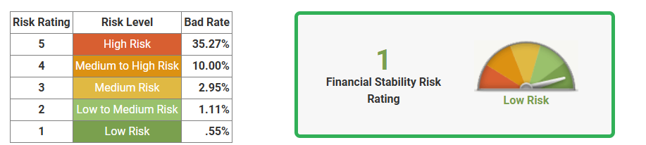

# Days Beyond Terms (DBT)

Current Days beyond terms: 60

Average industry days beyond terms: 15

|  |  |  |  |  |  |  |  |  |  |
| --- | --- | --- | --- | --- | --- | --- | --- | --- | --- |
| **Date** | **Current** | **Feb’25** | **Jan’25** | **Dec’24** | **Nov’24** | **Oct’24** | **Sept’24** | **Aug’24** | **July’24** |
| Company | 60 | 60 | 15 | 0 | 0 | 0 | 0 | 0 | 0 |
| Industry | 15 | 15 | 15 | 15 | 15 | 15 | 15 | 15 | 17 |

# Credit Utilization

Total Credit Limit of USD60,000

Available Credit – USD 19673

Credit Line Utilized – USD 40327

# Payment Trends

Monthly payment trends

|  |  |  |  |  |  |
| --- | --- | --- | --- | --- | --- |
| Date | Balance | Current | 0-30 DBT | 31-60 DBT | 61-90 DBT |
| Feb’25 | USD 1,346,600 | 98% | 0% | 2% | 0% |
| Jan’25 | USD 1,476,578 | 99% | 0% | 1% | 0% |
| Dec’24 | USD 1,345,678 | 94% | 6% | 0% | 0% |
| Nov’24 | USD 1.568.789 | 100% | 0% | 0% | 0% |
| Oct’24 | USD 1,322,400 | 100% | 0% | 0% | 0% |
| Sept’24 | USD 1,245,467 | 100% | 0% | 0% | 0% |
| Aug’24 | USD 1,065,400 | 100% | 0% | 0% | 0% |

# Credit Summary

Lowest 6 month balance: USD 1,135,000

Highest 6 month balance: USD 2.500,000

Highest credit amount extended: USD 70,000

Median credit amount extended: USD 3,035,600

Total current account balance: USD 2,467,890

# Public Records

|  |  |  |  |
| --- | --- | --- | --- |
| Type Status | Number | USD Value | Recent Date Filed |
| Bankruptcies | 0 | 0 | None reported |
| Judgements | 1 | 2675 | 11th March 2015 |
| Liens | 0 | 0 | None reported |

Judgements:

* Date: 11th march 2015
* Filing location: Dubai
* Legal type: judgement
* Legal action: Filed
* Document umber: 61681
* Liability amount: USD 2675

# Additional Information

Alternate Company Names: No information available

Owners and Guarantors Names:

|  |  |  |
| --- | --- | --- |
| **Owner and Guarantor Name** | **Type** | **Date reported** |
| John Doe | Guarantor | 10th March 2020 |
| Peter Pan | Guarantor | 2nd February 2023 |
| James Adams | Guarantor | 11th December 2023 |

Report Generated On: 15th March 2025